COMPARE AND CONTRAST THE FINANCIAL PERFORMANCES OF QANTAS AND AIR NEW ZEALAND
Executive Summary
The research report involves detailed analysis of the financial status and risk assessment status and analyst ratings. The financial analysis indicates that Air New Zealand is in a comparatively better position to Qantas Airways. Both the companies are in more or less the same position in terms of profitability. The risk assessment analysis indicates that the Air New Zealand is in a more risky position in comparison to Qantas Airways. The ratings analysis indicates that both the companies have the same position in terms of analyst ratings.

Introduction
The financial analysis of any company is incomplete if the analysis fails to reveal its performance relative to other competitors and more importantly to the industry average. Today there are an array of financial tools and techniques that make the comparison and contrasting of the financial performance completed with considerably less effort and time (Bajaj, 2001). In order to show how an array of techniques can be used to compare and contrast the financial performance, two companies are chosen from the aviation sector, Qantas and Air New Zealand. The choice of the two companies bears special importance (Bonaccorsi and Daraio, 2009). This is because of the reason that both the companies are some of the major players in the aviation sector and both of them represent two different parts of the world. The financial performance of the two companies involves detailed ratio analysis, risk assessment and rating provided by the analysts.

Description of Companies

Air New Zealand
Air New Zealand undertakes the transportation of cargoes and passengers mainly in the pacific Island, New Zealand and Australia, as well as USA, UK, Asia and Europe. It also provides different kind of engineering services like air motive, repair, ground handling, travel whole selling. Apart from these, it also provides services like aircrafts, maintenance of the components, overhaul services, booking systems and retailing services (Chrol, 2011). these services are mainly technical in nature. The company also specializes in giving non technical services like consultations in airlines management services. The consultation services includes network analysis and planning for marketing, management of fleet, review of risk analysis, analysis of integrity of the operations, providing start up advices and financial helps (Clark and Mathur, 2011). It also provides airlines operations analysis, for example, management of resources and schedule. The total market capitalization of the company is $ 1.57 billion and the enterprise value is $ 2.4 billion. The total trailing price/earnings value is $11.82 (intra-day).

Qantas Airways
Qantas is one of the major flag airlines of Australia. The company boasts of being the oldest carrier in Australia and in the world. It offers a wide variety of services like ground handling , logistics es, truck road feeder as well as courier services for small and medium scale enterprises and baggage services. Apart from these, there are also other kinds of services like the catering and defense services, (Das, Quelch and Swartz, 2000). The company has been offering innovative packages to those customers, who are required to fly frequently like the frequent flier loyalty programs (Flint, Woodruff and Gardial, S2002). The company operates two different types of aircrafts like the Qantas brands and the Frequent Flyer Loyalty Programs and as of now there are nearly 308 aircrafts.

Financial Analysis
Fig 1: Quick ratio
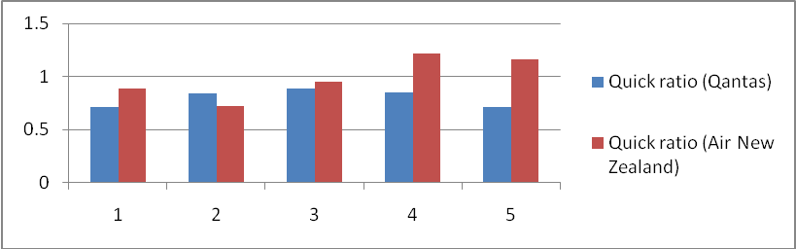
Source: (Lipe, 2013)
The quick ratio value indicates that the amount of current asset with respect to current liability for Qantas Airways is comparatively low with respect to Air New Zealand. This also indicates that Air New Zealand have been more successful in generating current asset by using current liabilities.
Fig 2: Current ratio
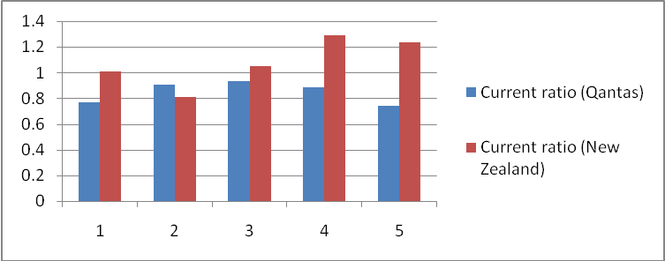
Source: (Lipe, 2013)
The current ratio indicates the amount of cash and those items that are quickly convertible to cash with respect to the current liabilities. Qantas Airways have less ability to support the current liabilities since the cash and cash convertible items per unit of current liability are significantly less than Air New Zealand.
Fig 3: Gross profit margin
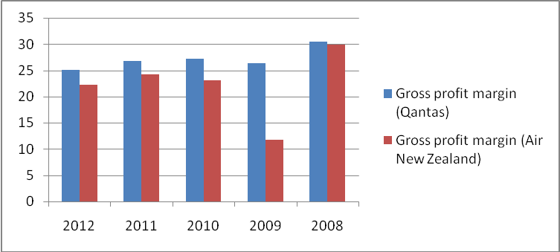
Source: (Lipe, 2013)
The gross profit margin of Qantas is significantly more than Air New Zealand. This can be mainly due to two different reasons one is the increase in the revenue due to the increase in the number of tickets sold. The other reason may be due to increase in the cost of sales (Flint, Woodruff and Gardial, 2002). Most of the airlines around the world are facing intense pressure owing to high cost of running the airlines. Air New Zealand may be witnessing the same rise in pressure in cost of sales.
Fig 4: Net profit margin
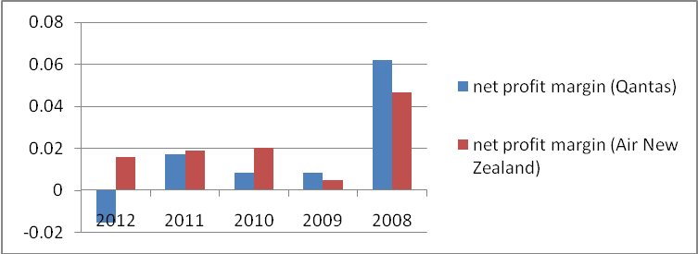
Source: (Lipe, 2013)
The net profit margin indicates the relation between the earnings after profit and tax and between revenue. The net profit margin analysis indicates that the earnings after tax and profit of both the companies are more or less same. This can be observed from the fact that the net profit margin of Qantas is significantly high in the year 2008, while in the other years the net profit margin of Air New Zealand is higher than that of Qantas (Garrick, 2011). Higher net profit margin indicates that the company is able to keep the operating income as well as the net income sufficiently high year in year.
Fig 5: Operating margin
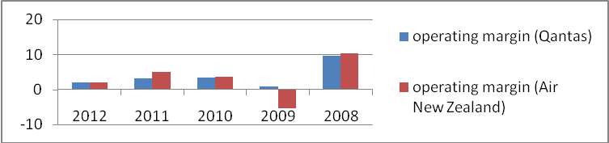
Source: (Lipe, 2013)
The operating margin analysis indicates that both the companies have been almost same in operating margin. The operating margin indicates the ability of the company to keep the operating expenses in control. A higher operating margin indicates that a company is able to keep control over the operating expenses (Ger, 2000). The analysis indicates that the both the companies Qantas and Air New Zealand has been able to keep a tight lid on the operating expenses.

Overall financial analysis
The financial analysis involved investigation of the liquidity and profitability. It can be concluded that in terms of profitability both the companies are almost same. Both the companies have shown same kind of variation in the profitability trend (Gina, 2013). During the 5 years phase starting from 2008 to 2013 there are intermittent periods when Qantas have registered higher profitability, while in other phases Air New Zealand generated higher profit margin. Although in the case of liquidity analysis, Air New Zealand is in a comparatively better position compared to Qantas. Thus, on an overall basis it can concluded that from financial point of view Air New Zealand is in a comparatively better position in comparison to Qantas.

Risk Assessment
Daily returns assessment

Qantas
Color Code | Indicator
Red | Market
Blue | Qantas

Fig 6: Daily returns assessment

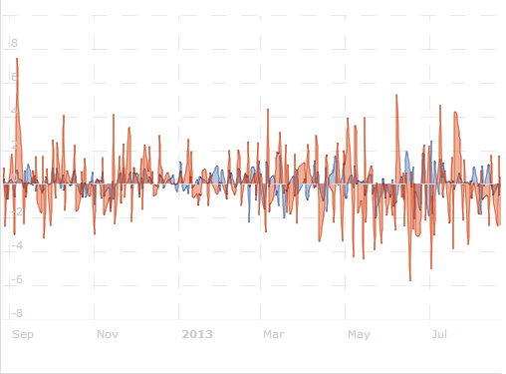
Source: (Lipe, 2013)
Daily returns of Qantas are less volatile than the daily market returns. This indicates daily returns of Qantas are less volatile.
Air New Zealand
Fig 7: Daily returns assessment

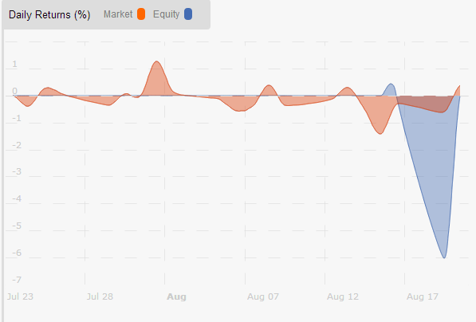
Source: (Lipe, 2013)
The daily return of the company is more volatile than the volatility of the market returns.
Volatility of the market returns of both the companies indicate that the Air New Zealand is more volatile in terms of daily returns than Qantas thus more risk (Graham and Campbell, 2012).
Calculation of the total risk
The total risk alpha indicates the way the assets of Qantas and New Zealand are performing. The returns of the companies are compared with the returns of the selected benchmark portfolio.
Table 1: Total risk analysis
Qantas | Total Risk Alpha | = | RFR + (ER[b] - ER[a]) | x | STD[a] / STD[b] | = | 0.11
Air New Zealand | Total Risk Alpha | = | RFR + (ER[b] - ER[a]) | x | STD[a] / STD[b] | = | 0.23
ER[a] | = | Expected return on investing in Qantas
ER[b] | = | Expected return on market index or selected benchmark
STD[a] | = | Standard Deviation of returns on Qantas
STD[b] | = | Standard Deviation of selected market or benchmark
RFR | = | Risk Free Rate of return. Typically T-Bill Rate
Source: (Lipe, 2013)
The comparisons of the total risk of the two companies indicate that Air New Zealand has increasingly more risk in comparison to Qantas.

Table 2: Current risk analysis
Current Risk Indicators | Air New Zealand | Qantas | Strong performer
Risk Adjusted Performance | 0.0217 | -0.04 | Air
Market Risk Adjusted Performance | 0.2085 | -0.38 | Air
Mean Deviation | 0.5265 | 1.16 | Qantas
Semi-Deviation | 1.02 | 2.71 | Air
Downside Deviation | 4.48 | 2.67 | Qantas
Coefficient Of Variation | 4999.87 | -1,127 | Qantas
Standard Deviation | 2.39 | 1.97 | Qantas
Source: (Lipe, 2013)
The comparisons of the current risk analysis indicate that the Qantas has a relatively strong position intern of risk factors in comparison to New Zealand Airways.
Fundamentals analysis
Table 3: Fundamental analysis
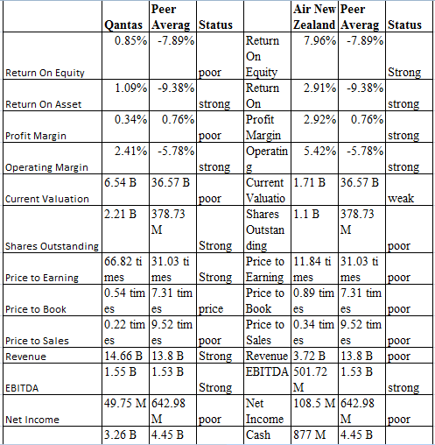
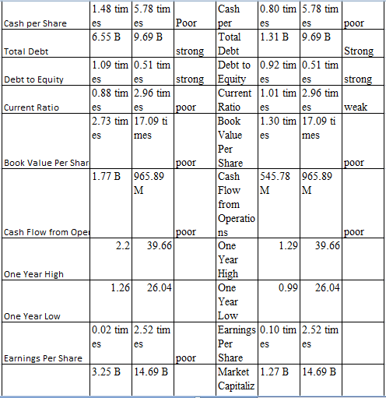
Source: (Lipe, 2013)
The fundamental analysis reveals the number of strong indicators for Qantas Airways is significantly more than the number of strong indicators than Air New Zealand. This is found out by tallying the number of strong and weak factors for each one of the companies. The analysis indicates that the number of strong factors of Qantas Airways is more than the number of strong factors of Air New Zealand (Ou, 2012).
Thus, on an overall basis it can be said that Qantas is relatively less risky in comparison to Air New Zealand.

Table 4: Analyst Ratings
Recommendation Summary* | Qantas | Air New Zealand
Mean Recommendation (this week): | 2.5 | 2
Mean Recommendation (last week): | 2.5 | 2
Change: | 0 | 0
Price Target Summary
Mean Target: | 1.63 | 1.85
Median Target: | 1.7 | 1.8
High Target: | 2.3 | 2.08
Low Target: | 1.2 | 1.72
No. of Brokers: | 13 | 5

Source: (Lipe, 2013)
The analyst’s ratings indicate that the share price of Qantas has the capability of reaching a value which is about 1.63 times its current value and this can occur 2.5 times a week. The median value of 1.7 indicates the increase in share price in the middle of the week. In the case of Air New Zealand the share prices increase by 1.85 times, which is more in comparison to the increase in the share price of Qantas. Although the mean number of times which indicates the number of times the increase may occur or may can take place is only 2 times. This is less than the number of times the increase on share price of Qantas is supposed to occur in a week(Graham and Campbell, 2012). So on an overall basis it can be opined that number of times share price will increase and the number of times the increase will take place in a week is different in both the case.

Recommendation & Conclusion
The financial analysis and the risk assessment analysis indicate two different trends. One is better financial position along with higher risk and the other trend is low financial position along with low risk. Qantas Airways is in a comparatively less risky position along with low financial soundness, while Air New Zealand is in comparatively high risk zone along with strong financial soundness. In order to improve the financial soundness, Qantas Airways should improve the liquidity status. The liquidity status can be improved by improving the current assets of the company. The current assets of the company can be improved by improving the cash contents and quickly convertible cash items. The risk factors of Air New Zealand can be improved by improving the current valuation, current ratio and intraday returns should be taken care.

Reference List
Bajaj, C., 2001. Foreign Collaborations: An innovative option. IIMB Management Review, 6(3), pp.142-145.
Bonaccorsi, A. and Daraio, C., 2009. Age effects in scientific productivity — the case of the Italian national research council (cnr). Scientometrics, 5(8), pp. 49–90.
Chrol, R. S., 2011. Evolution of the marketing organization: New forms for turbulent environments. Journal of Marketing, 5(5), pp. 77 – 93.
Clark, T. and Mathur, L. L., 2011. Global myopia: Globalisation theory in international business. Journal of International Management, 2(4), pp. 361–372.
Das, N., Quelch, J. and Swartz, G., 2000.Prepare your company for global pricing. Sloan Management Review, 42(1), pp. 61-70.
Flint, D. J., Woodruff, R. B. and Gardial, S. F., 2002. Exploring the phenomenon of customers’ desired value change in a business-to-business context. Journal of Marketing, 6(6), pp. 102 – 117.
Garrick, G., 2011. The evolution of organisational psychology in the 21st century. Journal of Organisational Research, 36(5), pp. 3-8.
Ger, G. 2000. Localizing in the global village: Local firm competing in global markets. California Management Review, 4(5), pp. 64 – 83.
Gina, G., 2013. Order from chaos: Who’s who in the republics. Journal of Strategic Marketing, 1(9), pp. 16–19.
Graham, J. R. and Campbell, R. H., 2012. The theory and practice of corporate finance: evidence from the field. Journal of Financial Economics, 6(5), pp. 187-243.
Lev, B. and Thiagarajan, S. R., 2013. Fundamental information analysis. Journal of Accounting Research, 3(1), pp. 190–215. (in-text not found)
Lipe, R. C., 2013. The information contained in the components of earnings. Journal of Accounting Research, 2(4), pp. 37–64.
Ou, J. A., 2012. The information content of non-earnings accounting numbers as earnings predictors. Journal of Accounting Research, 2(8), pp. 144–163.

